Colors, Gradients, Background Images

**1. Color**

Colors in CSS can be specified by the following methods:

* Hexadecimal colors
* RGB colors
* RGBA colors
* HSL colors
* HSLA colors
* Predefined/Cross-browser color names

## **1.1 Hexadecimal Colors**

A hexadecimal color is specified with: #RRGGBB, where the RR (red), GG (green) and BB (blue) hexadecimal integers specify the components of the color. All values must be between 00 and FF.

For example, the #0000ff value is rendered as blue, because the blue component is set to its highest value (ff) and the others are set to 00.

**Example:**

Define different HEX colors:

#p1 {background-color: #ff0000;} /* red */

#p2 {background-color: #00ff00;} /* green */

#p3 {background-color: #0000ff;} /* blue */

**Output:**

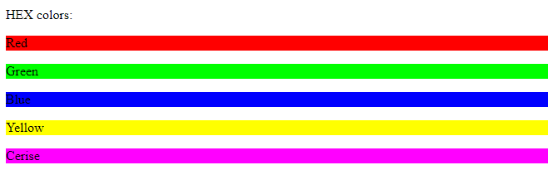

## **1.2 RGB Colors**

An RGB color value is specified with the [rgb() function](https://www.w3schools.com/cssref/func_rgb.asp), which has the following syntax:

rgb(red, green, blue)

Each parameter (red, green, and blue) defines the intensity of the color and can be an integer between 0 and 255 or a percentage value (from 0% to 100%).

For example, the rgb(0,0,255) value is rendered as blue, because the blue parameter is set to its highest value (255) and the others are set to 0.

Also, the following values define equal color: rgb(0,0,255) and rgb(0%,0%,100%).

### 

### **Example:**

Define different RGB colors:

#p1 {background-color: rgb(255, 0, 0);} /* red */

#p2 {background-color: rgb(0, 255, 0);} /* green */

#p3 {background-color: rgb(0, 0, 255);} /* blue */

**Output:**

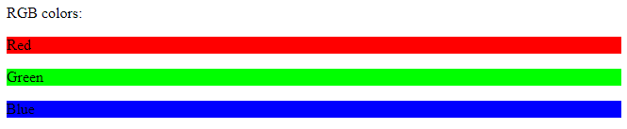

## 

## 

## 

## **1.3 RGBA Colors**

RGBA color values are an extension of RGB color values with an alpha channel - which specifies the opacity of the object.

An RGBA color is specified with the [rgba() function](https://www.w3schools.com/cssref/func_rgba.asp), which has the following syntax:

rgba(red, green, blue, alpha)

The alpha parameter is a number between 0.0 (fully transparent) and 1.0 (fully opaque).

### 

### **Example:**

Define different RGB colors with opacity:

#p1 {background-color: rgba(255, 0, 0, 0.3);} /* red with opacity */

#p2 {background-color: rgba(0, 255, 0, 0.3);} /* green with opacity */

#p3 {background-color: rgba(0, 0, 255, 0.3);} /* blue with opacity */

**Output:**

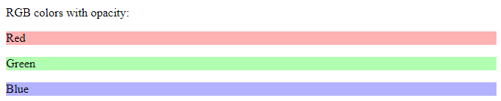

## 

## 

## 

## 

## 

## 

## **1.4 HSL Colors**

HSL stands for hue, saturation, and lightness - and represents a cylindrical-coordinate representation of colors.

An HSL color value is specified with the [hsl() function](https://www.w3schools.com/cssref/func_hsl.asp), which has the following syntax:

hsl(hue, saturation, lightness)

Hue is a degree on the color wheel (from 0 to 360) - 0 (or 360) is red, 120 is green, 240 is blue. Saturation is a percentage value; 0% means a shade of gray and 100% is the full color. Lightness is also a percentage; 0% is black, 100% is white.

### **Example**

Define different HSL colors:

#p1 {background-color: hsl(120, 100%, 50%);} /* green */

#p2 {background-color: hsl(120, 100%, 75%);} /* light green */

#p3 {background-color: hsl(120, 100%, 25%);} /* dark green */

#p4 {background-color: hsl(120, 60%, 70%);} /* pastel green*/

**Output:**

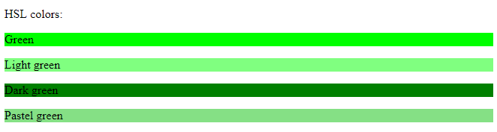

## 

## **1.5 HSLA Colors**

HSLA color values are an extension of HSL color values with an alpha channel - which specifies the opacity of the object.

An HSLA color value is specified with the [hsla() function](https://www.w3schools.com/cssref/func_hsla.asp), which has the following syntax:

hsla(hue, saturation, lightness, alpha)

The alpha parameter is a number between 0.0 (fully transparent) and 1.0 (fully opaque).

### **Example:**

Define different HSL colors with opacity:

#p1 {background-color: hsla(120, 100%, 50%, 0.3);} /* green with opacity */

#p2 {background-color: hsla(120, 100%, 75%, 0.3);} /* light green with opacity */

#p3 {background-color: hsla(120, 100%, 25%, 0.3);} /* dark green with opacity */

#p4 {background-color: hsla(120, 60%, 70%, 0.3);} /* pastel green with opacity */

**Output:**

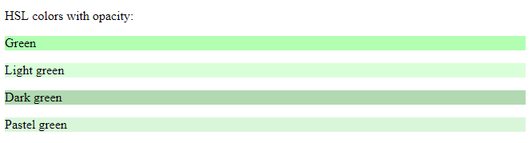

2. Backgrounds

The CSS background properties are used to define the background effects for elements.

**2.1 All CSS Background Properties**

|  |  |
| --- | --- |
| Property | Description |
| [background](https://www.w3schools.com/cssref/css3_pr_background.asp) | Sets all the background properties in one declaration |
| [background-attachment](https://www.w3schools.com/cssref/pr_background-attachment.asp) | Sets whether a background image is fixed or scrolls with the rest of the page |
| [background-clip](https://www.w3schools.com/cssref/css3_pr_background-clip.asp) | Specifies the painting area of the background |
| [background-color](https://www.w3schools.com/cssref/pr_background-color.asp) | Sets the background color of an element |
| [background-image](https://www.w3schools.com/cssref/pr_background-image.asp) | Sets the background image for an element |
| [background-origin](https://www.w3schools.com/cssref/css3_pr_background-origin.asp) | Specifies where the background image(s) is/are positioned |
| [background-position](https://www.w3schools.com/cssref/pr_background-position.asp) | Sets the starting position of a background image |
| [background-repeat](https://www.w3schools.com/cssref/pr_background-repeat.asp) | Sets how a background image will be repeated |
| [background-size](https://www.w3schools.com/cssref/css3_pr_background-size.asp) | Specifies the size of the background image(s) |

**2.2 Background-Color**

The background-color property specifies the background color of an element.

The element can be any html element

**Example**

body {

background-color: lightblue;

}

*With CSS, a color is most often specified by:*

* *a valid color name - like "red"*
* *a HEX value - like "#ff0000"*
* *an RGB value - like "rgb(255,0,0)"*

## **2.3 Background Image**

The background-image property specifies an image to use as the background of an element.

By default, the image is repeated so it covers the entire element.

The background image for a page can be set like this:

### **Example:**

body {

background-image: url("paper.gif");

}

**Looks Like:**



Note: When using a background image, use an image that does not disturb the text.

**2.3.1 Background-repeat**

If the image above is repeated only horizontally (background-repeat: repeat-x;), the background will look better:

### **Example:**

body {

background-image: url("gradient_bg.png");

background-repeat: repeat-x;

}

**Output:**



# 

# 

# 

# **3. background-origin**

The background-origin property specifies the origin position (the background positioning area) of a background image.

## **3.1 CSS Syntax:**

background-origin: padding-box|border-box|content-box|initial|inherit;

**3.2 Properties of background-origin**

|  |  |
| --- | --- |
| **Value** | **Description** |
| padding-box | Default value. The background image starts from the upper left corner of the padding edge |
| border-box | The background image starts from the upper left corner of the border |
| content-box | The background image starts from the upper left corner of the content |
| initial | Sets this property to its default value. |
| inherit | Inherits this property from its parent element. |

**Example:**

#example1 {

border: 10px double black;

padding: 25px;

background: url(img_tree.gif), url(paper.gif);

background-repeat: no-repeat;

background-origin: content-box, padding-box;

}

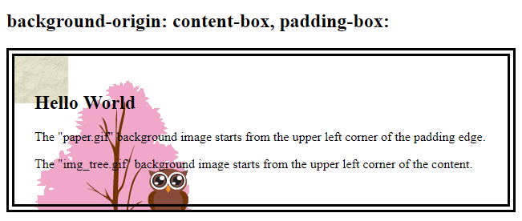

#example2 {

border: 10px double black;

padding: 25px;

background: url(img_tree.gif), url(paper.gif);

background-repeat: no-repeat;

background-origin: content-box, border-box;

}

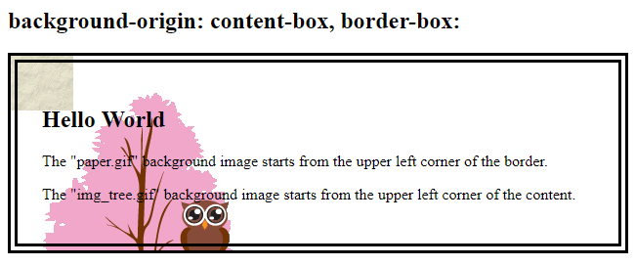

#example3 {

border: 10px double black;

padding: 25px;

background: url(img_tree.gif), url(paper.gif);

background-repeat: no-repeat;

background-origin: content-box, content-box;

}



**4.background-size**

The background-size property specifies the size of the background images.

There are four different syntaxes you can use with this property: the keyword syntax ("auto", "cover" and "contain"), the one-value syntax (sets the width of the image (height becomes "auto"), the two-value syntax (first value: width of the image, second value: height), and the multiple background syntax (separated with comma).

## **CSS Syntax:**

background-size: auto|*length*|cover|contain|initial|inherit;

## **Property Values:**

|  |  |
| --- | --- |
| Value | Description |
| auto | Default value. The background image is displayed in its original size |
| length | Sets the width and height of the background image. The first value sets the width, the second value sets the height. If only one value is given, the second is set to "auto". |
| percentage | Sets the width and height of the background image in percent of the parent element. The first value sets the width, the second value sets the height. If only one value is given, the second is set to "auto" |
| cover | Resize the background image to cover the entire container, even if it has to stretch the image or cut a little bit off one of the edges |
| contain | Resize the background image to make sure the image is fully visible |
| initial | Sets this property to its default value. |
| inherit | Inherits this property from its parent element. |

**REFERENCES**

1. **https://www.w3schools.com/css/css_colors.asp**
2. **https://www.w3schools.com/css/css_background.asp**